Problem Statement

Create HTML website of an online electronics store with below mentioned requirements

You should have 3 pages in your website index.html, contact.html & about.html.

In all 3 pages you should have a banner image on the top with the size of 960px X 275px. The banner image should have a border of 1px and aligned to center of the page. Use external stylesheet to reuse the same style across all the web pages.

Below the banner image, in all 3 pages you should have hyperlinks like - Home, AboutUs, ContactUs to navigate from one page to another. Remove the underline from the hyperlinks using CSS.

On index.html page display 4 product images in the same row with the size of 180px X 200px alongwith a solid black border of 1px. Use embedded stylesheet to reuse the style across all the images.

In contact.html display the contact details of different offices of the store in bulleted list as mentioned below

Registered Office

38, down street, New York, United States

Ph. 123-345-4567

Corporate Office

128, Silicon Valley, California, United States

Ph. 987-765-5432

In addition display the heading as Contact Us in green color with font size 20pt. Use inline stylesheet to achieve the same.

In about.html page display the heading as About Us in grey color with font size 20pt. Use inline stylesheet to achieve the same. Also write some text in paragraph.

The home page should appear as shown in the following figure.

HomePage

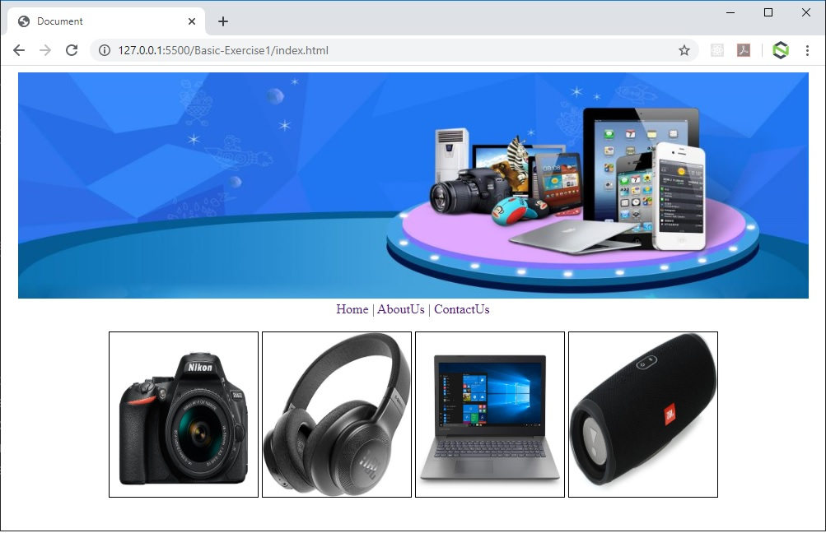

The About page should appear as shown in the following figure.

AboutPage

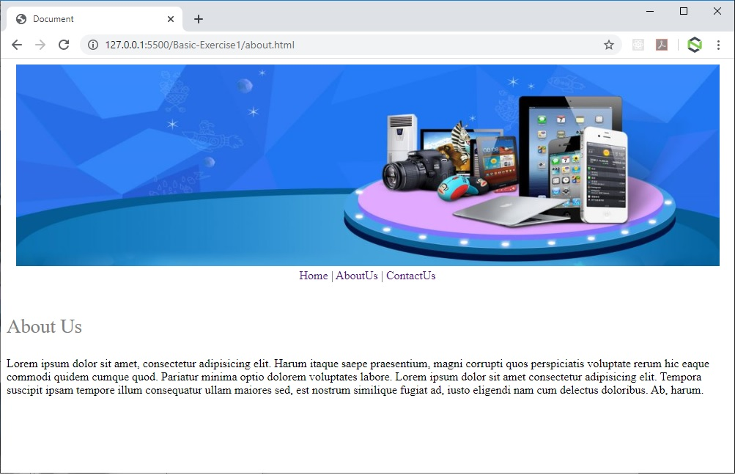

The Contact page should appear as shown in the following figure.

ContactPage

